|  |  |  |  |  |  |
| --- | --- | --- | --- | --- | --- |
| Table 1: Multivariate Statistics for MANOVA (OVERALL) | | | | | |
| Effect | | Value | F- Value | Sig. | Observed Power |
| Main Effect: Gender | Pillai's Trace | .009 | 1.056b | .368 | .286 |
| Wilks' Lambda | .991 | 1.056b | .368 | .286 |
| Hotelling's Trace | .009 | 1.056b | .368 | .286 |
| Roy's Largest Root | .009 | 1.056b | .368 | .286 |
| Main Effect:  Q7 – How did you watch this movie? | Pillai's Trace | .070 | 2.847 | .003 | .965 |
| Wilks' Lambda | .931 | 2.868 | .002 | .914 |
| Hotelling's Trace | .074 | 2.877 | .002 | .967 |
| Roy's Largest Root | .054 | 6.400c | <.001 | .968 |
| Interaction: Gender * Q7 – How did you watch this movie? | Pillai's Trace | .023 | .907 | .519 | .460 |
| Wilks' Lambda | .977 | .905 | .520 | .370 |
| Hotelling's Trace | .023 | .904 | .521 | .459 |
| Roy's Largest Root | .017 | 2.050c | .107 | .524 |
| a. Design: Intercept + Gender + Q7 + Gender * Q7 | | | | | |
| b. Exact statistic | | | | | |
| c. The statistic is an upper bound on F that yields a lower bound on the significance level. | | | | | |

|  |  |  |  |  |  |  |  |  |  |
| --- | --- | --- | --- | --- | --- | --- | --- | --- | --- |
| Table 2.  Two-Factor ANOVA Predicting Q23g. When I like a TV show, sometimes I buy the complete season on DVD or other media | | | | | | | | | |
|  | Mean | *sd* | *n* | Sum of Squares | *df* | Mean Square | F | Sig. | Partial eta2 |
| Main Effect: Gender |  |  |  | 8.024 | 1 | 8.024 | 1.694 | .194 | .005 |
| 1 Male | 3.62 | 2.186 | 141 |  |  |  |  |  |  |
| 2 Female | 3.44 | 2.246 | 222 |  |  |  |  |  |  |
| Main Effect: Q7. How did you watch this movie? |  |  |  | 69.841 | 3 | 23.280 | 4.916 | .002 | .040 |
| 1 In theater | 3.59ab | 2.129 | 85 |  |  |  |  |  |  |
| 2 On TV/cable | 3.31a | 2.302 | 84 |  |  |  |  |  |  |
| 3 Via DVD/BluRay | 4.21b | 2.281 | 90 |  |  |  |  |  |  |
| 4 Online | 3.01a | 2.041 | 104 |  |  |  |  |  |  |
| Interaction:  Gender X Q7 |  |  |  | 27.845 | 3 | 9.282 | 1.960 | .120 | .016 |
| Male/In theater | 3.52 | 2.098 | 42 |  |  |  |  |  |  |
| Female/In theater | 3.65 | 2.181 | 43 |  |  |  |  |  |  |
| Male/On TV/cable | 4.42 | 2.317 | 19 |  |  |  |  |  |  |
| Female/On TV/cable | 2.98 | 2.211 | 65 |  |  |  |  |  |  |
| Male/Via DVD/BluRay | 4.27 | 2.140 | 33 |  |  |  |  |  |  |
| Female/Via DVD/BluRay | 4.18 | 2.376 | 57 |  |  |  |  |  |  |
| Male/Online | 2.94 | 2.068 | 47 |  |  |  |  |  |  |
| Female/Online | 3.07 | 2.034 | 57 |  |  |  |  |  |  |
| Error |  |  |  | 1681.2 | 355 | 4.736 |  |  |  |
| Corrected Total |  |  |  | 1786.7 | 362 |  |  |  |  |

NOTE: The grand mean for this analysis was 3.51

NOTE: For the main effect of Q7, those means that do not share a superscript are significantly different at *p* < .05.

Figure 1. Nearly near-significant interaction of gender and Q7 in the prediction of Q23g.

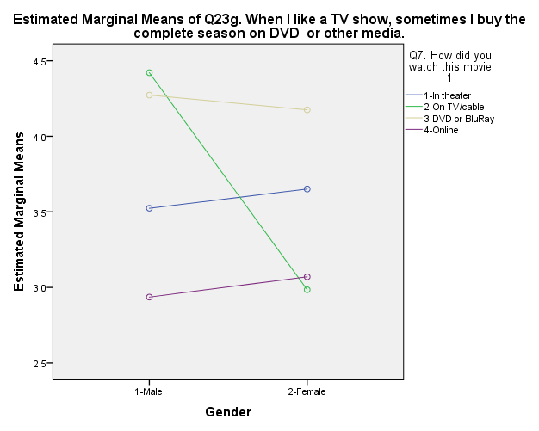

|  |  |  |  |  |  |  |  |  |  |
| --- | --- | --- | --- | --- | --- | --- | --- | --- | --- |
| Table 3.  Two-Factor ANOVA predicting Q23i. I have a collection of DVDs and/or BlueRays | | | | | | | | | |
|  | Mean | *sd* | *n* | Sum of Squares | *df* | Mean Square | F | Sig. | Partial eta2 |
| Main Effect: Gender |  |  |  | .033 | 1 | .033 | .007 | .932 | .000 |
| 1 Male | 4.22 | 2.091 | 141 |  |  |  |  |  |  |
| 2 Female | 4.43 | 2.229 | 222 |  |  |  |  |  |  |
| Main Effect: Q7. How did you watch this movie? |  |  |  | 69.835 | 3 | 23.278 | 5.084 | .002 | .041 |
| 1 In theater | 4.00a | 2.121 | 85 |  |  |  |  |  |  |
| 2 On TV/cable | 4.43ab | 2.251 | 84 |  |  |  |  |  |  |
| 3 Via DVD/BluRay | 5.03b | 2.036 | 90 |  |  |  |  |  |  |
| 4 Online | 3.97a | 2.156 | 104 |  |  |  |  |  |  |
| Interaction:  Gender X Q7 |  |  |  | 19.782 | 3 | 6.594 | 1.440 | .231 | .012 |
| Male/In theater | 3.95 | 2.071 | 42 |  |  |  |  |  |  |
| Female/In theater | 4.05 | 2.193 | 43 |  |  |  |  |  |  |
| Male/On TV/cable | 5.05 | 1.985 | 19 |  |  |  |  |  |  |
| Female/On TV/cable | 4.25 | 2.305 | 65 |  |  |  |  |  |  |
| Male/Via DVD/BluRay | 4.94 | 1.968 | 33 |  |  |  |  |  |  |
| Female/Via DVD/BluRay | 5.09 | 2.090 | 57 |  |  |  |  |  |  |
| Male/Online | 3.62 | 2.038 | 47 |  |  |  |  |  |  |
| Female/Online | 4.26 | 2.224 | 57 |  |  |  |  |  |  |
| Error |  |  |  | 1625.4 | 355 | 4.579 |  |  |  |
| Corrected Total |  |  |  | 1714.3 | 362 |  |  |  |  |

NOTE: The grand mean for this analysis 4.35

|  |  |  |  |  |  |  |  |  |  |
| --- | --- | --- | --- | --- | --- | --- | --- | --- | --- |
| Table 4.  Two-Factor ANOVA Q23j. Often we watch movies in the car on trips, short or long. | | | | | | | | | |
|  | Mean | *sd* | *n* | Sum of Squares | *df* | Mean Square | F | Sig. | Partial eta2 |
| Main Effect: Gender |  |  |  | .088 | 1 | .088 | .023 | .879 | .000 |
| 1 Male | 2.56 | 1.822 | 141 |  |  |  |  |  |  |
| 2 Female | 2.57 | 2.003 | 222 |  |  |  |  |  |  |
| Main Effect: Q7. How did you watch this movie? |  |  |  | 9.070 | 3 | 3.023 | .805 | .492 | .007 |
| 1 In theater | 2.85 | 2.027 | 85 |  |  |  |  |  |  |
| 2 On TV/cable | 2.33 | 1.922 | 84 |  |  |  |  |  |  |
| 3 Via DVD/BluRay | 2.57 | 1.949 | 90 |  |  |  |  |  |  |
| 4 Online | 2.52 | 1.843 | 104 |  |  |  |  |  |  |
| Interaction:  Gender X Q7 |  |  |  | 5.375 | 3 | 1.792 | .477 | .699 | .004 |
| Male/In theater | 2.90 | 1.948 | 42 |  |  |  |  |  |  |
| Female/In theater | 2.79 | 2.122 | 43 |  |  |  |  |  |  |
| Male/On TV/cable | 2.47 | 1.837 | 19 |  |  |  |  |  |  |
| Female/On TV/cable | 2.29 | 1.958 | 65 |  |  |  |  |  |  |
| Male/Via DVD/BluRay | 2.58 | 1.871 | 33 |  |  |  |  |  |  |
| Female/Via DVD/BluRay | 2.56 | 2.009 | 57 |  |  |  |  |  |  |
| Male/Online | 2.28 | 1.664 | 47 |  |  |  |  |  |  |
| Female/Online | 2.72 | 1.971 | 57 |  |  |  |  |  |  |
| Error |  |  |  | 1333.9 | 355 | 3.758 |  |  |  |
| Corrected Total |  |  |  | 1351.2 | 362 |  |  |  |  |

NOTE: The grand mean for this analysis was 2.56